WHAT DOESN’T KILL YOU MAKES YOU STRONGER

Or: What was most likely to kill you in the 1800’s

Wars, Disease, Famine: A walking tour

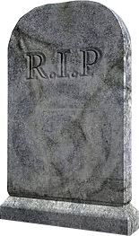

[This Photo](https://pngimg.com/download/42467) by Unknown Author is licensed under [CC BY-NC](https://creativecommons.org/licenses/by-nc/3.0/)

Join the Nashville City Cemetery as we tour to find graves of those killed by the Cholera Epidemics of 1849, 1850, 1866